Microsoft Azure - Starter Kits for Partners

Hands on Lab

Archiving and Backup

SQL Server Backup

Last Update: September 2015



MICROSOFT MAKES NO WARRANTIES, EXPRESS, IMPLIED OR STATUTORY, AS TO THE INFORMATION IN THIS DOCUMENT.

The information contained in this document represents the current view of Microsoft Corporation on the issues discussed as of the date of publication. Because Microsoft must respond to changing market conditions, it should not be interpreted to be a commitment on the part of Microsoft, and Microsoft cannot guarantee the accuracy of any information presented after the date of publication.

Complying with all applicable copyright laws is the responsibility of the user. Without limiting the rights under copyright, no part of this document may be reproduced, stored in or introduced into a retrieval system, or transmitted in any form or by any means (electronic, mechanical, photocopying, recording, or otherwise), or for any purpose, without the express written permission of Microsoft Corporation.

Microsoft may have patents, patent applications, trademarks, copyrights, or other intellectual property rights covering subject matter in this document. Except as expressly provided in any written license agreement from Microsoft, the furnishing of this document does not give you any license to these patents, trademarks, copyrights, or other intellectual property.

The descriptions of other companies’ products in this document, if any, are provided only as a convenience to you. Any such references should not be considered an endorsement or support by Microsoft. Microsoft cannot guarantee their accuracy, and the products may change over time. Also, the descriptions are intended as brief highlights to aid understanding, rather than as thorough coverage. For authoritative descriptions of these products, please consult their respective manufacturers.

© 2015 Microsoft Corporation. All rights reserved. Any use or distribution of these materials without express authorization of Microsoft Corp. is strictly prohibited.

Microsoft and Windows are either registered trademarks of Microsoft Corporation in the United States and/or other countries.

The names of actual companies and products mentioned herein may be the trademarks of their respective owners.

Contents

Overview 5

Objectives 5

Prerequisites 5

Exercises 6

SQL Server 2014 Manual backup to Azure Storage 6

SQL Server 2014 Manages Backup to Azure Storage 13

Summary 18

Additional References 18

## Overview

Microsoft Azure Infrastructure as a Service (IaaS) platform will enable you to:

* Quickly create and manage your infrastructure.
* Provisioning and accessing any host ubiquitously.
* Grow your business through the cloud-based infrastructure.
* Reduce the costs of licensing, provisioning and backup.

In this hands-on Lab, you will learn how to backup and restore databases to Azure Storage.

**Note:** Due to constant changes in the Azure Portal this document may not reflect the most recent updates. We suggest that you consult the following online links that provide the most up-to-date steps to install and deploy a Azure Backup Vault. It includes steps to deploy:

**Scenario 1:** SQL Server Backup and Restore with Azure Blob Storage Service

<https://msdn.microsoft.com/en-us/library/jj919148(v=sql.110).aspx>

**Audience**: IT Pro, Architect, Application Owners and Developers

### Objectives

In this hands-on lab, you will learn how to:

* Automatically backup and restore databases to Azure storage.
* Manual backup and restore databases to Azure storage.

### Prerequisites

The following is required to complete this hands-on lab:

* A Microsoft Azure subscription - [sign up for a free trial](http://aka.ms/WATK-FreeTrial)
* Local or cloud-based installation of SQL Server 2014
* AdventureWorks2012 database

## Exercises

This hands-on lab includes the following exercises:

1. **SQL Server 2014 Manual backup to Azure Storage**
2. **SQL Server 2014 Manages Backup to Azure Storage**

Estimated time to complete this lab: **30 min**

## SQL Server 2014 Manual backup to Azure Storage

[**Before you begin**](javascript:void(0))

1. Create a storage account subscription in Windows Azure.
2. Have a Storage Access Keyavailable, along with a subscription identity.
3. Create a container named **Backup** in the storage container.
4. Have either a local or a cloud-based installation of **SQL Server 2014** with the **AdventureWorks2012** database installed.

**Tasks**

SQL Server 2014 gives you the ability to back up SQL Server databases to an Azure storage container. First introduced in SQL Server 2012 SP1 CU2, SQL 2014 has expanded this ability to include a graphical experience in SQL Server Management Studio.

1. Start **SQL Server Management Studio**, and then connect to the local instance of SQL Server 2014.
2. Expand the **Security** folder, right-click **Credentials**, and then click **New Credential**.
3. In the **New Credential** dialog box, complete the following:

* In the **Credential** name box, type *mycredential.*
* In the **Identity** box, type the *storage account name*.
* In the **Password** box, type either the *Primary Access Key* or *Secondary Access Key* for the storage account.

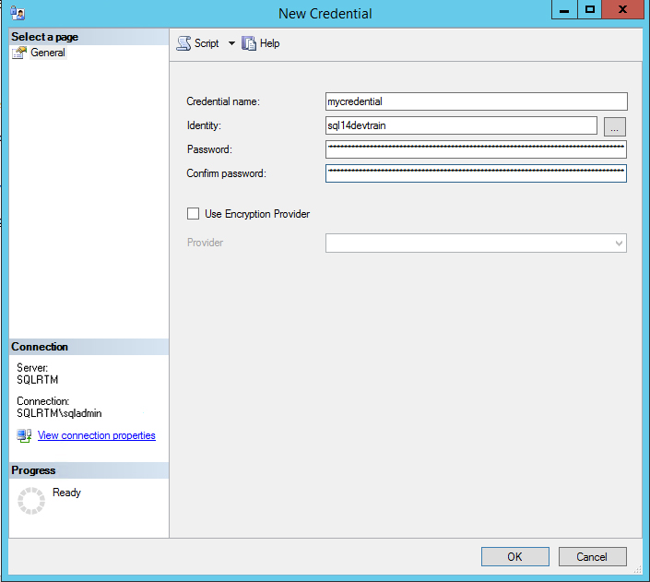

**Note**: Alternatively, you can run the **CREATE CREDENTIAL T-SQL** code, substituting the same information.

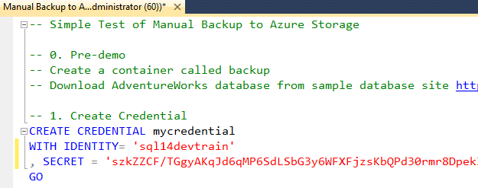

Once you create the Azure credentials, you can back up databases to the Azure storage account. In this demo, we back up the AdventureWorks2012 database.

1. In **SQL Server Management Studio**, expand the **Databases** folder, right-click on the **AdventureWorks2012** database, click **Tasks**, and then click **Backup** to start the backup database dialog.

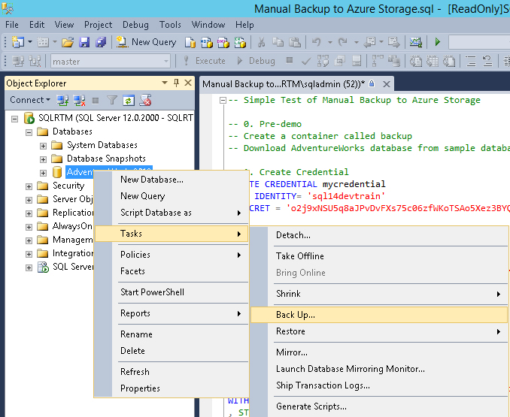

1. In the **Back Up Database – AdventureWorks2012** dialog, change the destination to **URL**. Use the following information for the dialog:

* File name: *AdventureWorks2012Test1.bak*
* SQL credential: *mycredential*
* Azure storage container: *backup*
* URL prefix: *https://<yourcontainer>.blob.core.windows.net/backup*

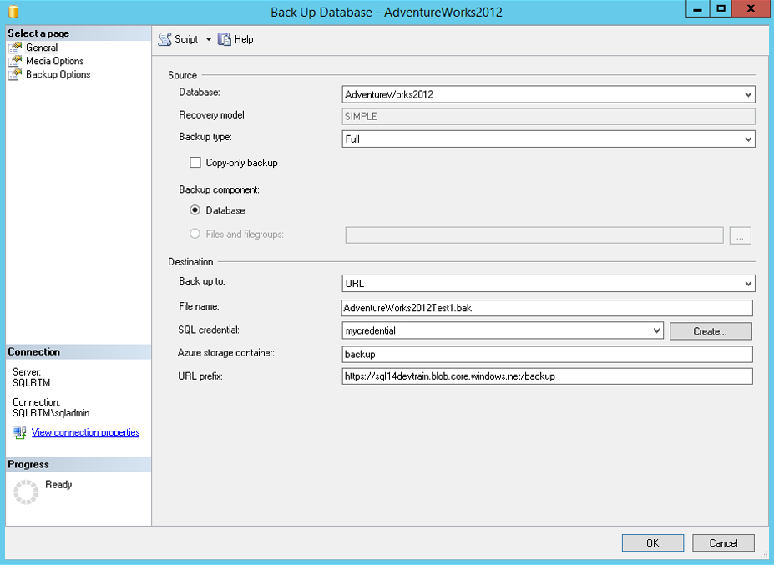

1. To launch the backup, click **OK**.

**Note**: Alternatively, you can run the **T-SQL BACKUP DATABASE** command, modifying the URL as explained above.

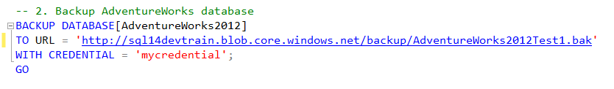

Once the backup has completed, you can drop the AdventureWorks2012 database, and then restore it from the backup in the Azure storage container.

1. In **SQL Server Management Studio**, drop the database (Step 3 in the T-SQL script).

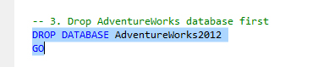

**Note**: Alternatively, you can right-click on **AdventureWorks2012** in the database list, expand the **Databases** folder, right-click on the **AdventureWorks2012** database, and select **Tasks → Backup** to start the backup database dialog.

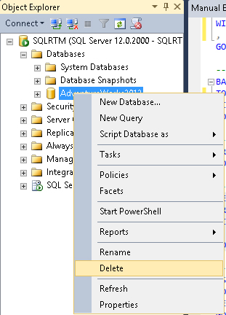

1. Right-click on the **Databases** folder and select **Restore Database** to launch the **Restore Database** dialog box.
2. In the source option, select **Device**, and then click on the **…** box to launch the **Select backup devices** dialog.
3. Change the backup media type to **URL** to make the **Connect to Azure Storage** dialog appear. Specify the account and Account Key, click the **Save account key** checkbox, and then select to use the **mycredential** credential you previously created. Then, click **Connect**.

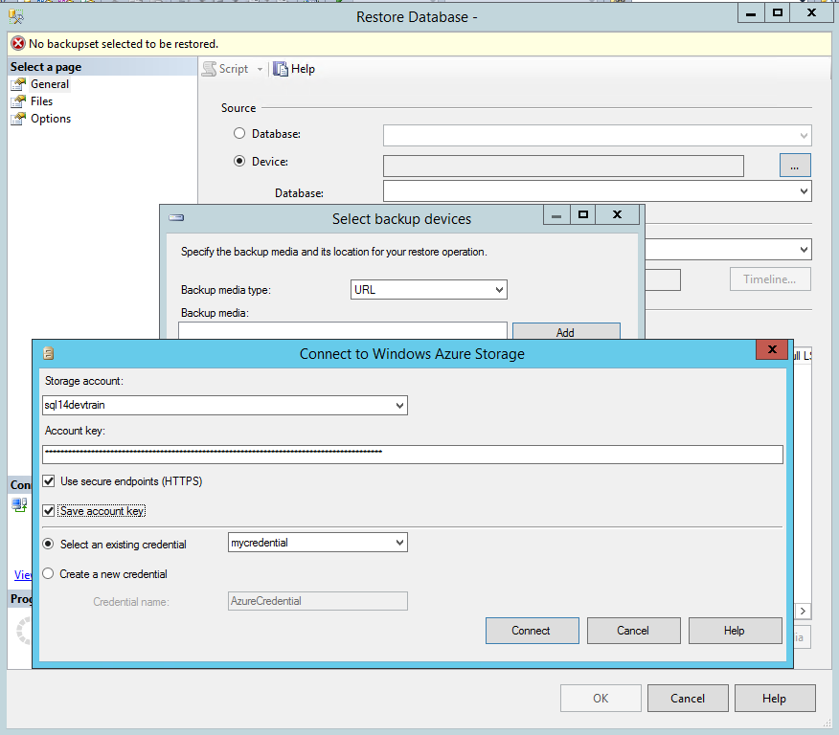

1. 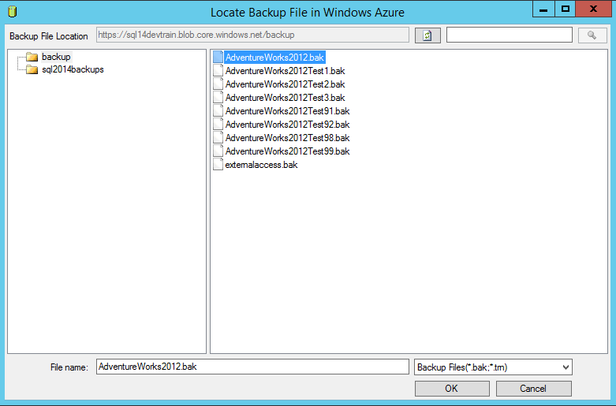Select the **AdventureWorks2012.bak** file from the list of backup files presented. Click **OK**, and then click **OK** again on the **Select backup devices** dialog.
2. Notice that the restore header information is read, and then the restore plan is created. Once the dialog shows **Ready**, click **OK** to begin the restore.

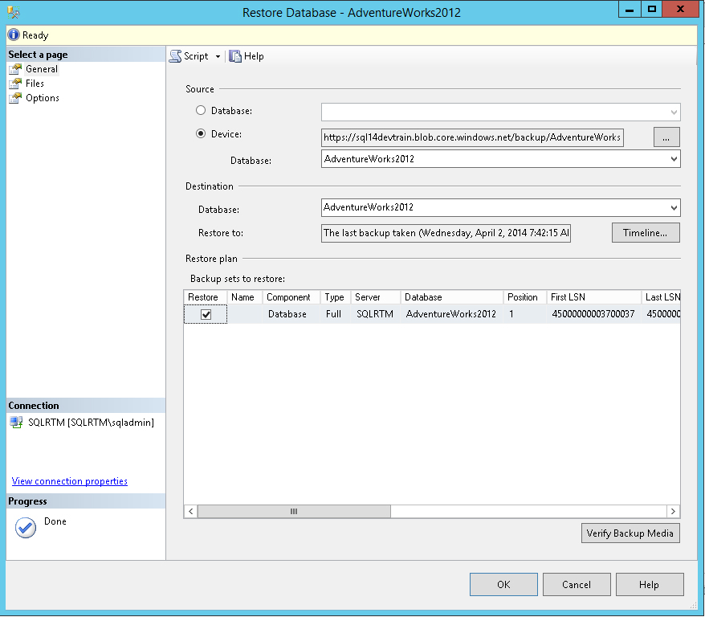

**Note**: Alternatively, you can run the **RESTORE DATABASE T-SQL** command, substituting the URL you used to perform the backup.

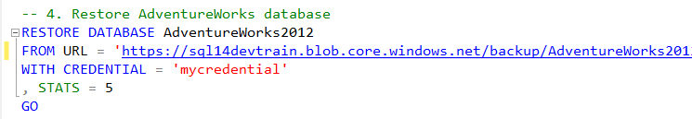

1. Once the restore has completed, run a simple query in the **Query** window to demonstrate that the database has been restored.

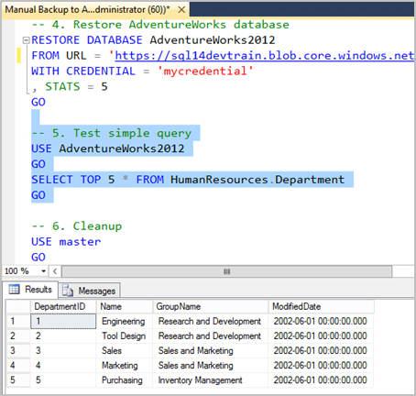

## SQL Server 2014 Manages Backup to Azure Storage

1. Create a Storage account subscription in Windows Azure (named **sql14devtrain** in this demo).
2. Have your Storage Access Key available, along with your subscription identity.
3. Create a container named **backup** in your storage container with default access as **Private**.
4. Have either a local or a cloud-based installation of SQL Server 2014 with the AdventureWorks2012 database installed. Ensure that the **SQLServerAgent** service is running.
5. Change the recovery model of Adventureworks2012 to **FULL**.

Note: Additionally you also can download the SQL Server Backup to Microsoft Azure Tool <http://www.microsoft.com/en-in/download/details.aspx?id=40740>

## Summary

In this hands-on Lab, you have learnt how to automatically and manually backup and restores databases to Azure Storage.

## Additional References

* [Introduction to SQL Server 2014 Hybrid Cloud](http://msdn.microsoft.com/en-us/library/dn606154.aspx)